

Dear Consumer:

Thank you for your interest in a loan to purchase assistive technology through the Arizona Loans for Assistive Technology Program (AzLAT). Enclosed, you will find the loan application. Answer each question completely, attach any additional documentation as necessary, and mail the application to our office. The AzLAT Review Board will not consider incomplete or faxed applications.

Keep in mind that in order to be eligible for a loan, applicants must meet the following requirements:
- Be a legal Arizona resident.
- Be a person with a disability or a family member/significant other on behalf of a person with a disability and legally able to enter into a contract.
- Provide assurance that the loan will be used to purchase assistive technology devices and/or services. (The assistive technology can be for a person with a disability regardless of age or type of disability as long as its use is intended to improve the individual’s functional capabilities).
- Document sufficient creditworthiness and ability to repay the loan.
- Request a loan in an amount ranging from $500 - $20,000.
- Have a valid checking account from which our financial institution will be authorized to make monthly debits for the repayment of the loan.
- If your loan is approved, you will establish an account with MariSol Federal Credit Union with a $25 membership deposit.

Our Loan Review Committee meets monthly. For a loan to be reviewed at that time, the completed application with proof of income, invoice from the vendor(s) for the total purchase price of the assistive technology must be received by the first Tuesday of the month.

If you have any questions or feel that you require assistance or an alternative format to complete the application form, please contact me at martha.lewis@nau.edu, 602-776-4670, 800-477-9921 (toll-free) or 602-728-9536 (TTY).

Sincerely,
Martha Lewis
Loan Program Specialist

Enclosures

Arizona Loans for Assistive Technology
Arizona Technology Access Program
300 W. Clarendon Ave., Suite 475, Phoenix, AZ 85013 (Voice) 602-776-4670 (Toll-Free) 800-477-9921
(TTY) 602-728-9536 Website: www.aztap.org
Date Received:

ID Number:

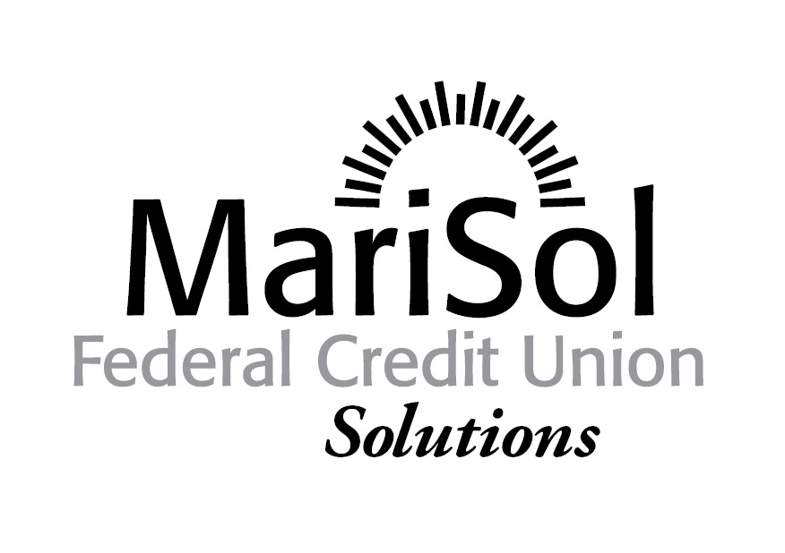

MariSol Federal Credit Union Loan Application

All information on this application form is strictly confidential and will only be used to determine your need for and ability to repay this loan. Borrowers must demonstrate the ability to repay the loan.

Completion of this form does not guarantee that a loan will be granted. Please print or type:

- Name of person with a disability: Age:

Describe the disability of the person who will be using the assistive technology: ________________________________________________________________

- Please check the box that best describes the relationship between the person with a disability and the borrower(s):◻ SELF ◻ SPOUSE/PARTNER ◻ PARENT ◻ CHILD
◻ GUARDIAN ◻ Other (specify) ________________________________________

- Explain how the assistive technology devices/equipment will affect independence, education, and/or employment (please be specific): _________________________________________________________________

- Describe the type of assistive technology equipment or service to be purchased (use specific item brand names):

- Total Loan amount requested $____________. You must attach an itemized price quote from each vendor regarding the device(s) you intend to purchase with this loan. Initials:

- Specify the loan request below:
 | AzLAT Loan | Other funding source(s): ___________
Equipment | $ | $
Installation | $ | $
Insurance | $ | $
Service Agreements | $ | $
Maintenance and Repair | $ | $
Evaluation and/or Training Services | $ | $
Applicable Taxes | $ | $
Other (Specify) | $ | $
Total loan amount requested from AzLAT | $
Total funding from other source(s) |  | $

- For home modifications in excess of $1,000 it is strongly recommended that you submit two (2) bids from licensed, bonded contractors. Initials: _____________

- Will this equipment be attached to an auto? ◻ YES ◻ NO
- Is the vehicle in your name? ◻ YES ◻ NO

- Is there a lien holder? ◻ YES ◻ NO

$
(Lender) (Loan balance)

- Provide the following information for the vehicle:
Year: Make: ___________ Model: ____Mileage __________

9. Provide the information requested below for the borrower and co-borrower (if applicable):
 | Borrower | Co-Borrower
a. Name
b. Social Security #
c. Date of Birth | Month/day/year  / / | Month/day/year  / /
d. Mailing Address
e. City/State/Zip
f. Phone | ( ) | ( )
g. Email
h. Are you a legal Arizona Resident? | ◻ YES ◻ NO | ◻ YES ◻ NO

10. Provide employment information for the borrower and co-borrower (if applicable):
 | Borrower | Co-Borrower
a. Employed? | ◻ YES ◻ NO | ◻ YES ◻ NO
b. Occupation:
c. Date employed:
d. Employer & address:
e. Work phone #
f. Secondary Employer & address:
g. Work phone #

11. Include a list of all current sources of monthly income. Printed verification of income must be attached to the application.
 | Borrower | Co-Borrower
- Employment (gross income) | $ | $
- Temporary Assistance for Needy Families | $ | $
- Social Security | $ | $
- Social Security Supplemental Income (SSI) | $ | $
- Social Security Disability Insurance (SSDI) | $ | $
- Pension/Retirement | $ | $
- Private Disability Benefits | $ | $
- Rental Income (2 years tax returns required) | $ | $
- Child Support and or Alimony (Include if to be considered for repayment of this obligation) | $ | $
j. General Assistance (GA) | $ | $
k. Veteran Benefits | $ | $
l. Other: Specify | $ | $
TOTALS | $ | $

- Please provide verification of income sources for the borrower and co-borrower (if applicable):
 | Borrower | Co Borrower
a. SSI/SSDI Benefits Statement or award letter: | ☐ YES ☐ NO | ☐ YES ☐ NO
b. Alimony - copy of court order | ☐ YES ☐ NO | ☐ YES ☐ NO
c. Child Support - copy of court order attached | ☐ YES ☐ NO | ☐YES ☐ NO
d. Spousal Maintenance - copy of court order attached | ☐ YES ☐ NO | ☐YES ☐NO
e. If employed, please attach copy of pay stubs for the last  three (3) months | ☐YES ☐ NO | ☐ YES ☐ NO
f. If no other income documentation is available, attach copy of tax returns for the past two (2) years | ☐ YES ☐ NO | ☐ YES ☐ NO
g. Other income (specify) - documentation attached | ☐ YES ☐ NO | ☐ YES ☐ NO

- Have you ever filed for Bankruptcy? ◻ YES ◻ NO
When and why did you file for bankruptcy? ________________________________ _________________________________________

- List total monthly payments of all your financial obligations: If necessary, use an additional sheet of paper.
Borrower’s financial obligations:
Obligation | Creditor | Balance | Monthly Payment
Rent ( Attach lease) |  | $ | $
Mortgage (attached statement) |  | $ | $
Car loan |  | $ | $
Car Loan |  | $ | $
Car Loan |  | $ | $
Credit Card |  | $ | $
Credit Card |  | $ | $
Credit Card |  | $ | $
Credit Card |  | $ | $
Personal Loan |  | $ | $
Personal Loan |  | $ | $
Personal Loans |  | $ | $
Title loan |  | $ | $
Other Loans |  | $ | $
 | Total Monthly Debt Payment |  |  | $

Co-borrower’s financial obligations:
Obligation | Creditor | Balance | Monthly Payment
Rent ( Attach lease if different than borrower’s) |  | $ | $
Mortgage (attach statement if different than borrower’s) |  | $ | $
Car loan |  | $ | $
Car Loan |  | $ | $
Car Loan |  | $ | $
Credit Card |  | $ | $
Credit Card |  | $ | $
Credit Card |  | $ | $
Credit Card |  | $ | $
Personal Loan |  | $ | $
Personal Loan |  | $ | $
Personal Loan |  | $ | $
Title Loan |  | $ | $
Other Loans |  | $ | $
 | Total Monthly Debt Payment |  | $

- List the name(s) and locations of your financial institution(s) and the account number(s) of your checking, savings, or other account(s):

Bank Name |  | Bank Name
Type of Account | ◻ Checking ◻ Savings ◻ Other (specify)_____________ | Type of Account | ◻ Checking ◻ Savings ◻ Other (specify)_____________
Account Number |  | Account Number
Balance | $ | Balance | $

- There is no loan application fee. However, if your loan is approved and you accept it, you agree to open an account at MariSol with a $25 membership deposit. Initials____
- If you do not have an account with a financial institution, you understand and agree to open an account with a financial institution* for the electronic transfer of funds as a condition for receiving a loan from this program: Initials: ____
* You are not required to repay your loan through your account at MariSol; an existing account at another financial institution for electronic transfer of funds is acceptable.

- Please provide an explanation of any credit issues or problems that you have. ________________________________ ________________________________________________________________
________________________________ ______________________
___________________________________________________________________________

Application Disclosures

Individual Credit:
You must complete the applicant section about yourself and the Co-borrower section about your spouse if:
1. You live in or the property pledged as collateral is located in a community property state (Arizona, California, Idaho, Louisiana, New Mexico, Nevada, Texas, Washington or Wisconsin)
2. Your spouse will use the account or
3. You are relying on your spouse’s income as a basis of repayment. If you are relying on income from alimony, child support or separate maintenance, complete the Co-borrower section to the extent possible about the person whose payment you are relying on.

Joint Credit:
If you are applying with another person, complete the applicant and Co-applicant sections.

If there are important changes, you will notify MariSol in writing immediately. You will also agree to notify us of any change in your name, address or employment within a reasonable time thereafter. You also promise that everything you have stated in this application is correct to the best of your knowledge and that the above information is complete listing of your debts and obligations. You authorize MariSol Federal Credit Union to obtain credit reports and share these reports with AzLAT in connection with this application for credit and for any update, renewal or extension of the credit received. If you request, MariSol will tell you the name and address of any credit bureau from which it received a credit report on you. You understand that it is a Federal Crime to willfully and deliberately provide incomplete and incorrect information on loan application made to the Federal Credit Unions or State Charter Credit union insured by NCUA.

__________________________________ ________________________________
Borrower Signature Date: Co-Borrower Signature Date

APPLICATION CHECKLIST

Before submitting your application, make sure to…

- Complete all parts of the application

- Sign and date the application in ink where signatures are required

- Attach copies of all required income verifications such as SSI/SSDI Benefits Statement or award letter, copy of court ordered Alimony, child support, or maintenance, tax returns, or pay stubs

- Attach a legible copy of your AZ Driver’s License or State ID Card.

- Attach lease agreement if renting or mortgage statement if you own the home.

- Attach vendor price quotes for the Assistive Technology equipment or services you want to purchase.

- Attach two (2) bids, if applicable, from licensed contractors for home modifications in excess of $1,000.00

Mail the completed application to:

Martha Lewis
Arizona Loans for Assistive Technology
c/o AzTAP
300 W Clarendon Ave., Suite 475
Phoenix, AZ 85013

If you have questions or need assistance completing the application, contact Martha Lewis at 602.776.4670, 800.477.9921 or martha.lewis@nau.edu.

